Adversarial Helper Work

- Swelling of the body: when the helper first engages the dog with a threat; the helper should make direct eye contact starring with their arms down by their side, as the helper starts stalking or moving toward the dog, the helper will start widening their body by bringing arms out wider and moving the arms to a position where they look coiled for a strike or an attack; once a dog sees this type of posture it will instinkly view this type of posture as a threat. The helper is imitating body posturing that animals use in nature such as a cobra snake, a chicken protecting her young or fighting and this swelling of the body is done by most all animals when facing a threat or when they are threatening. People use this type of body posturing when making threats or when they are angry and ready for confrontation.
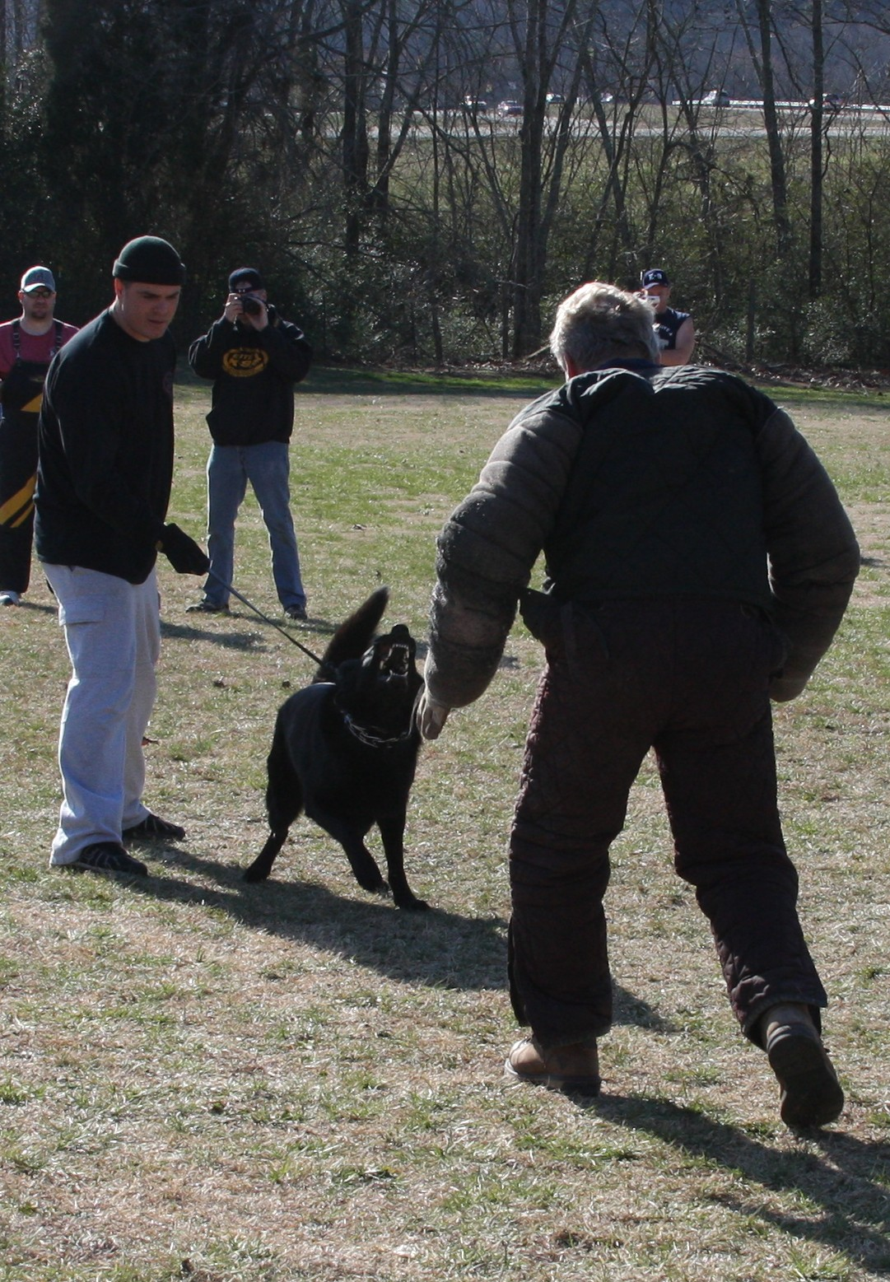
Example of the helper swelling the body and a constant eye stare just prior to the attack where the dog can grip. In this photo I was swelling my body, using direct eye starring and was moving in a slow staking approach just prior to making my attack movement for the grip.

- Direct Eye Starring & KEEPING THE Dog Engaged: direct eye starring is very confrontational to a dog and is the main area of the helper’s body that the dog will look at for reading a threat. Many accidental dog bites are caused by people that walk up and just start starring at a dog and then move. Helpers can keep a dog engaged in a protection routine by just moving from location to location by always starring or making direct eye contact with dog.

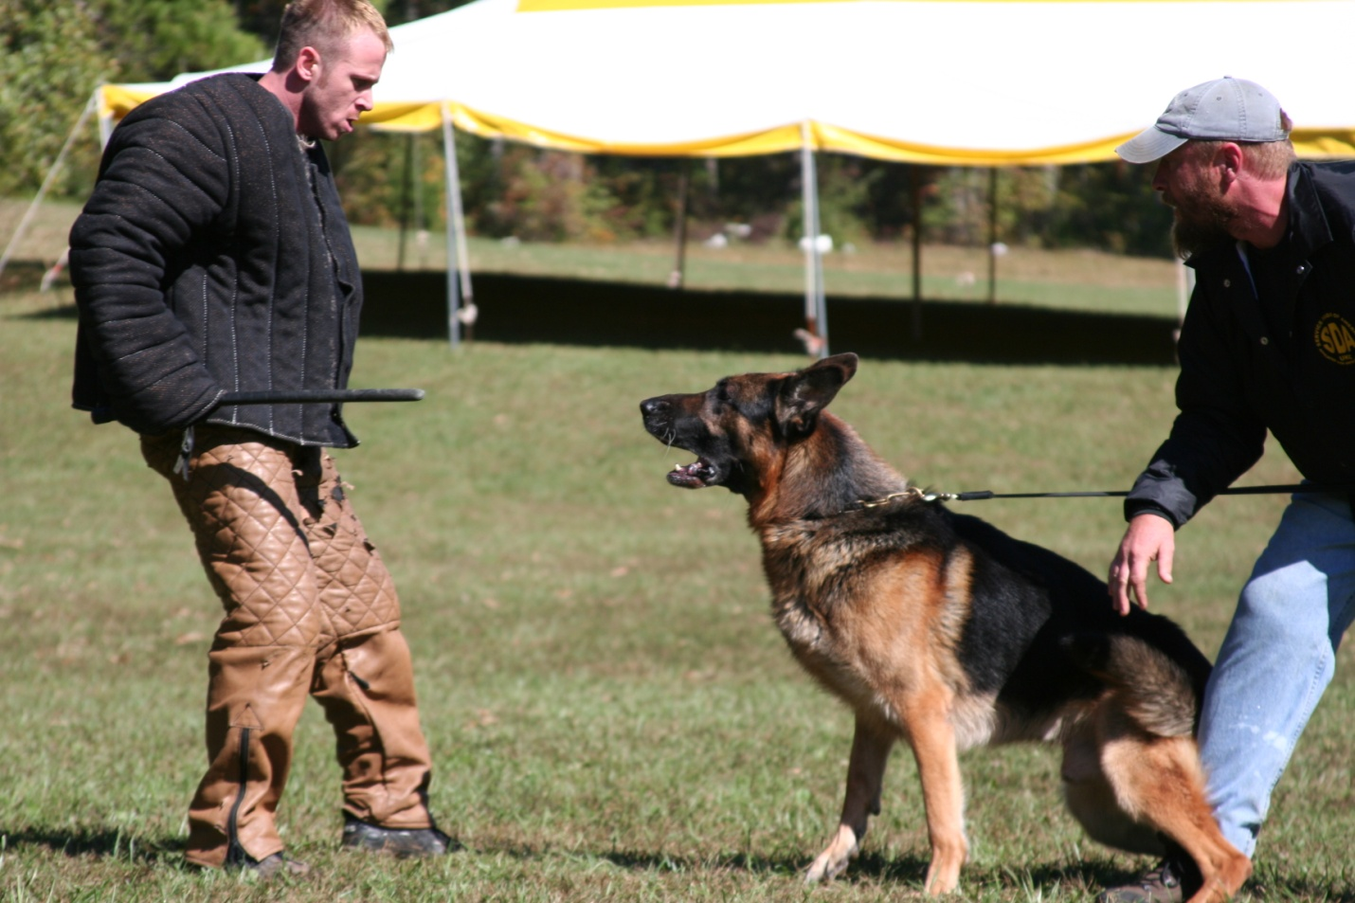
The above helper had just threaten the dog with stick and was starting his retreat to move to next position; notice the eye starring and body posture the helper is maintaining to keep the dog engage.
- Stalking movements: when the helper makes direct eye contact and their body is swollen and coiled; they will start moving toward the dog in a slow manner that makes the dog think an attack is coming. This type body position is demonstrated best by lions prior to an attack, most lions lock on to their target with a direct stare and then start coiling their bodies and moving slowly then exploding into an attack; this type of movement is very adversarial to dog.

The following are pictures that display adversary demeanor

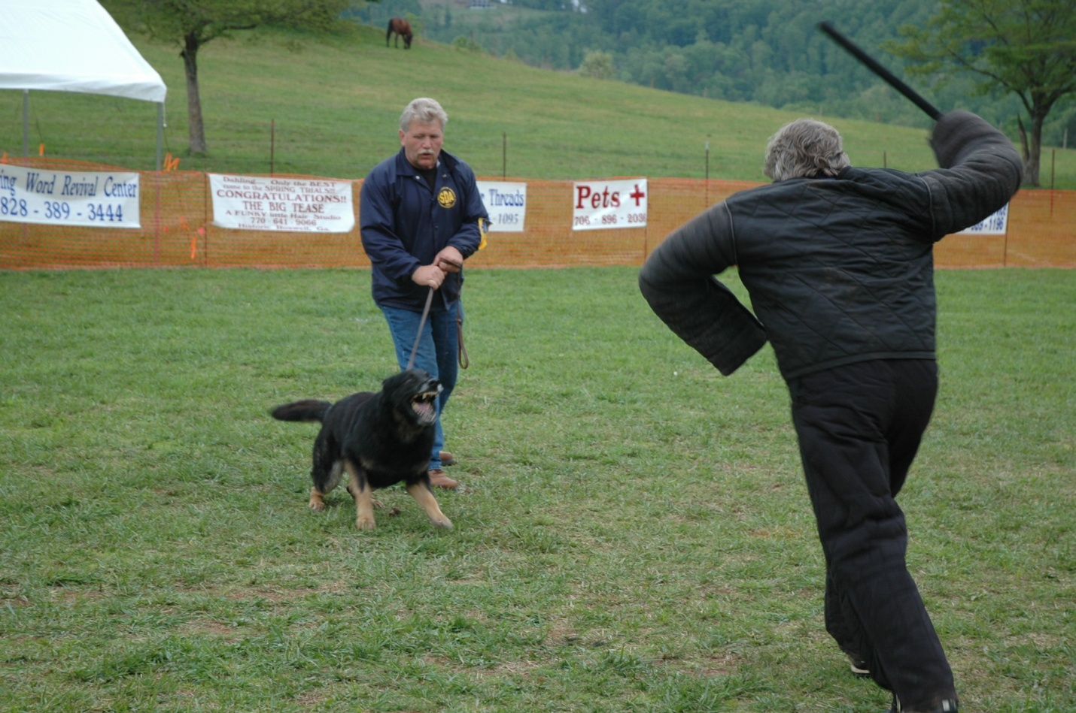

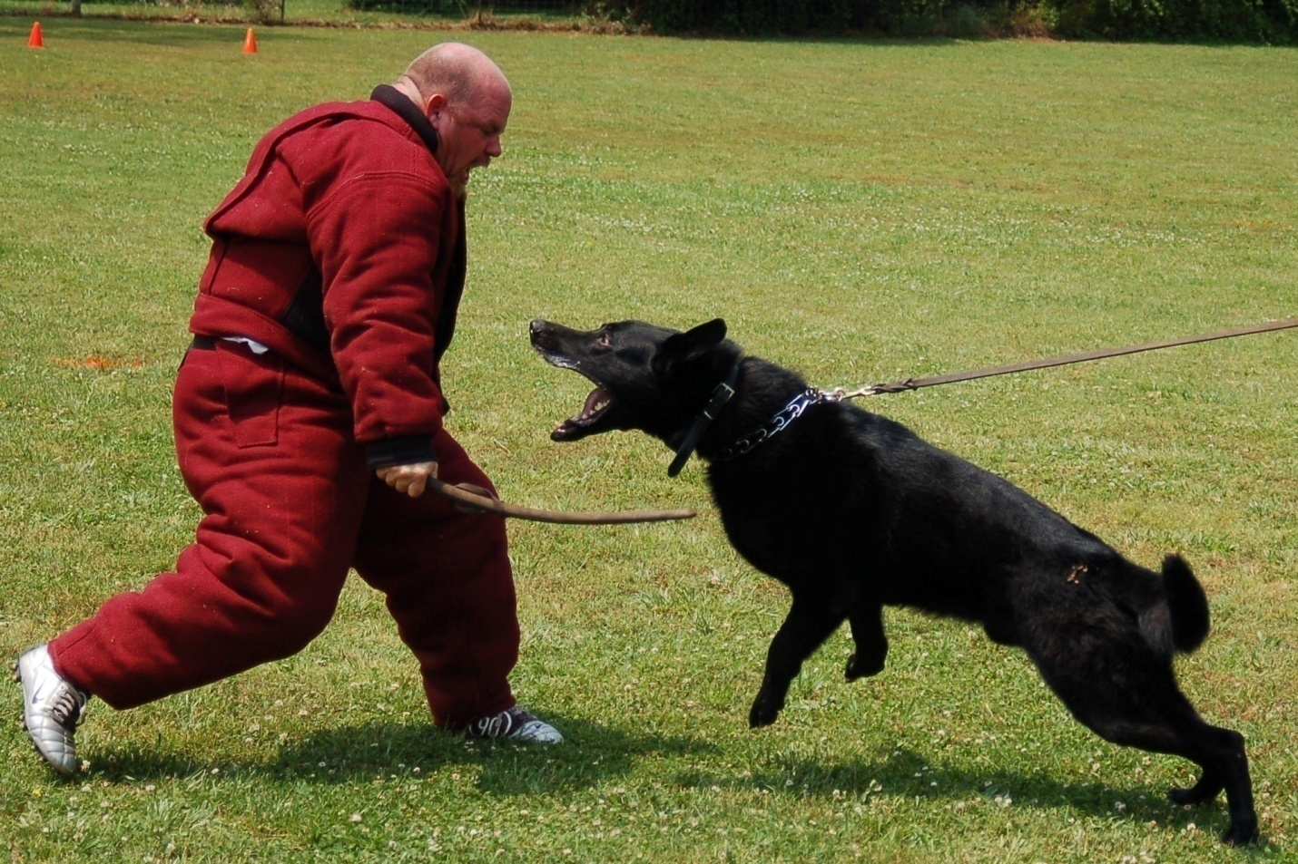
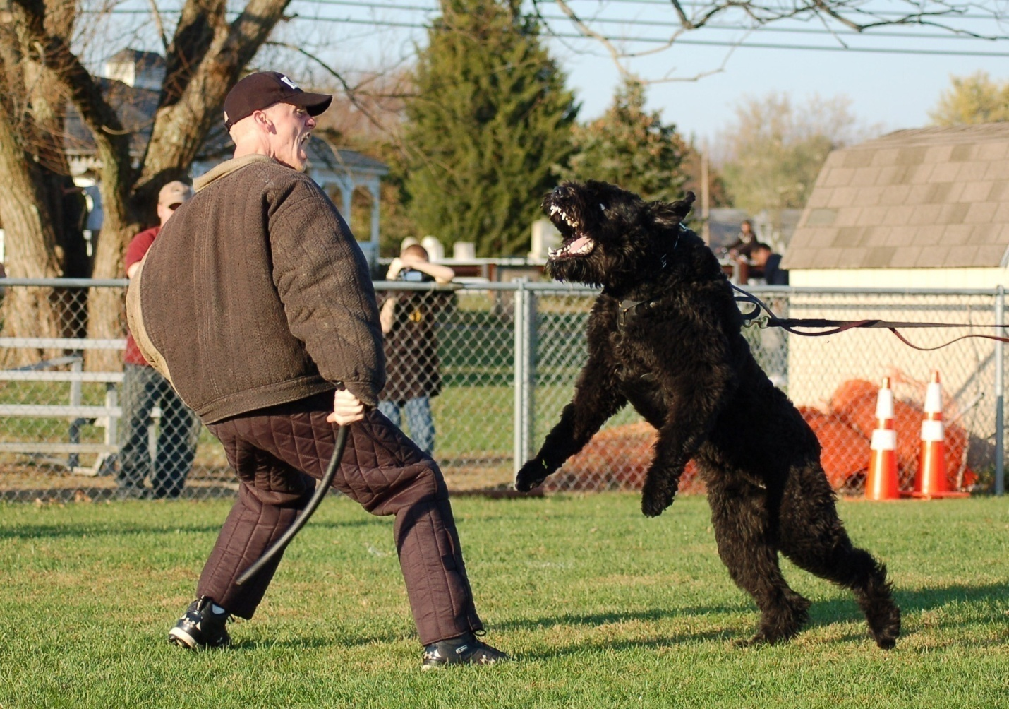

- Attack Driving using the Stick: we at SDA encourage helpers to use an attack style of driving while using the stick; this is accomplished by the helper engaging the dog with a grip and then going directly into the dog with some form of skip drive were the helper start pushing the dog directly backward while providing heavy threats and maintaining direct eye contact on the dog during the drive. The helper’s job is to provide a very threatening attack that really challenges the dog! Also, during the attack driving, the helper can use verbal threats.

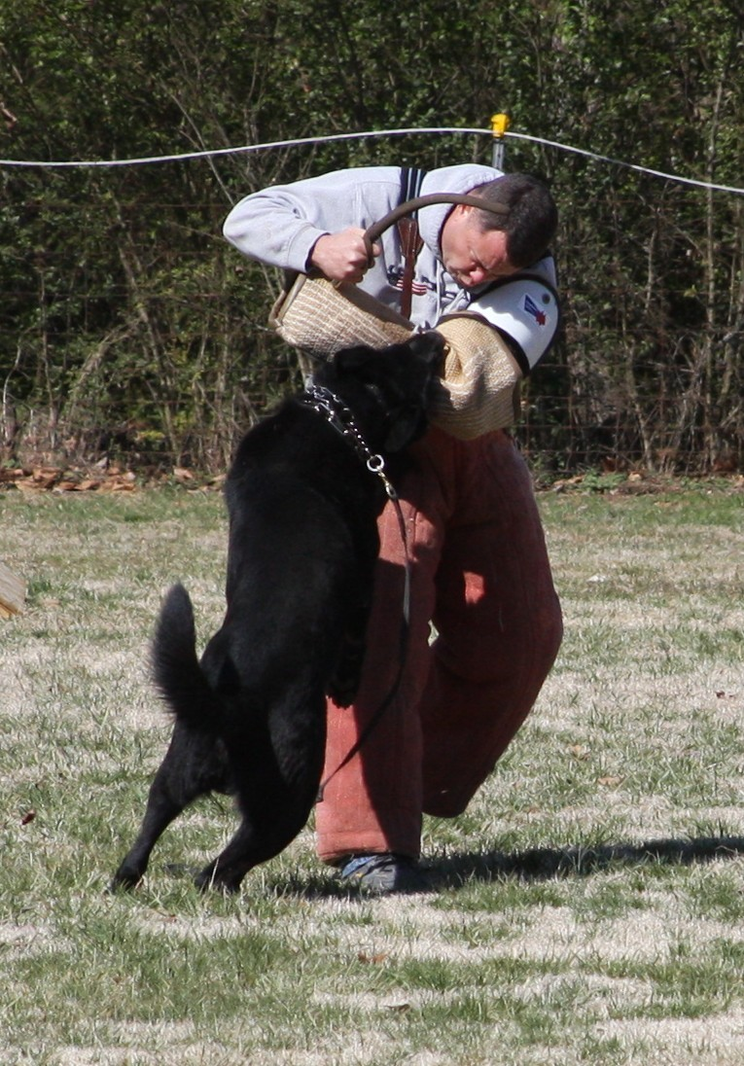

- Verbal Threats; SDA helpers are encouraged to use verbal threats when they are first engaging a dog or when they applying other threats.
- Last, Helpers must practice adversarial techniques often to master them; this is accomplished by the helper using them often in their regular training. These type techniques can be performed at various degrees of intensity that a dog can take; however using these techniques often prepares your dog for what the dog may see in a SDA Trial or real life.

